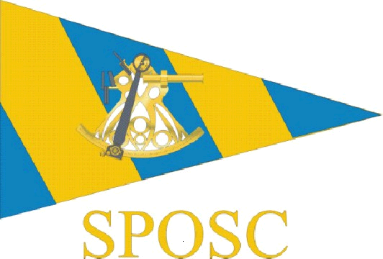
  - Sussex Police Offshore Sailing Club
  - Skipper & Crew Risk Assessment Form
  - The Risk Assessment Form does not take the place of the “Skippers Safety Briefing”, but must be used in conjunction with that briefing.
Charter Details
Date of Event/Signing
Yacht Name
Skipper
1st Mate
I have been given a safety briefing by the Skipper and am aware of the risks as described in the SPOSC Risk Assessment Form. I accept that sailing can be a dangerous activity. I confirm that I have declared any medical condition that I am aware of to the Skipper & that I am fit to participate in this event.
The skipper has explained that the yacht Security Deposit has been provided by SPSA/SPOSC. An Insurance claim may be made for loss or damage to vessel or equipment except the excess which will be the responsibility of the crew in equal parts. It is the responsibility of the Skipper to ensure the crew are aware of the amount of the excess ascertained from the charter company who should consider any charters insurance that may reduce the excess amount. Any loss or damage to vessel or equipment where a claim is not made is the responsibility of the crew for which the Skipper will resolve with the charter.
All crew members are advised to ensure that they have adequate Personal Insurance cover
 | Name Printed | Signed
1
2
3
4
5
6
7
8
9
10
11
12
* This form, fully completed must be returned to the SPOSC Secretary on completion of the Charter.
**Damage &/or injury was/was not sustained on this charter. Signed.....................................................................Skipper.
*** if damage/injury did occur the Skipper will submit a separate report to the SPOSC Committee.

Alwyn Evans 01/2015

