

j0343921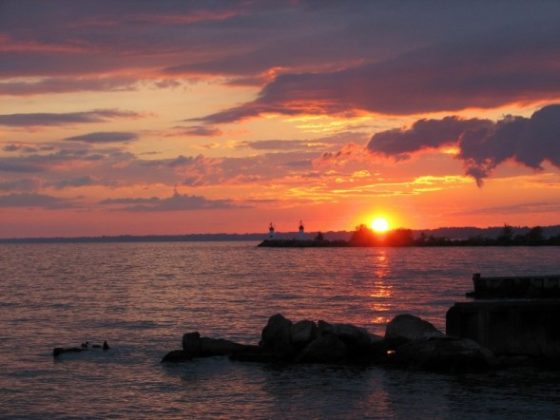Scuttlebutt

*Newsletter of the*

*Sussex Police*

*Offshore Sailing Club*

Issue 163

July 2009

Scuttlebutt No. 163

July edition 2009

\*\*\*\*\*\*\*\*\*\*\*\*\*\*\*\*\*\*\*\*\*\*\*\*\*\*\*\*\*\*\*\*\*\*\*\*\*\*\*\*\*\*\*\*

**CONTENTS**

1. **Caribbean Adventure**
2. **Training & Cross Channel opportunity**
3. **Our Charities**
4. **Cyprus Holiday Offer**

\*\*\*\*\*\*\*\*\*\*\*\*\*\*\*\*\*\*\*\*\*\*\*\*\*\*\*\*\*\*\*\*\*\*\*\*\*\*\*\*\*\*

COMMITTEE

Senior Flag Officer Commodore – Terry Clothier

##### OFFICERS OF THE CLUB

Chairman……………… Steve Rigby

Vice Chair……………. Freya Carter

Sec…………………… Julia Beckett

Treasurer……………… Alwyn Evans

Assistant Treasurer …… Jonathan Lelliott

## Asst. Sec and Membership Donna Powell

\*\*\*\*\*\*\*\*\*\*\*\*\*\*\*\*\*\*\*\*\*\*\*\*\*\*\*\*\*\*\*\*\*\*\*\*\*\*\*\*\*\*

### REPRESENTATIVES

**West Downs** - Gill Hooton

**Brighton & Hove** Lindsey Valder-Davis

**North Downs** - Alan Haffenden

**East Sussex** - Donna Powell

**HQ** - Kevin Wallis

**Sussex House** - Martin Cheesman

**Gatwick -** Mark Osborn

\*\*\*\*\*\*\*\*\*\*\*\*\*\*\*\*\*\*\*\*\*\*\*\*\*\*\*\*\*\*\*\*\*\*\*\*\*\*\*\*\*\*

SCUTTLEBUTT

Editor ……………………… Terry Clothier [terryclothier@hotmail.com](mailto:terryclothier@hotmail.com)

Mediterranean Correspondent… John Sumner [johnsumner@wanadoo.fr](mailto:johnsumner@wanadoo.fr)

Caribbean Correspondent … Peter Kennett [peterkennett3@aol.com](mailto:peterkennett3@aol.com)

USA & Pacific Rim Correspondent Mark Hayler [vossen26@bellsouth.net](mailto:vossen26@bellsouth.net)

**Cover Photo – Sunset over Lake Eyrie by Emma Clothier**

**Tall Ships Youth Trust**

**Grenada to Antigua February 2009**

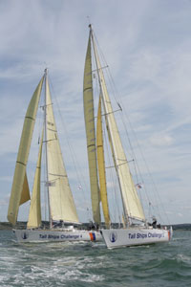**by Alwyn Evans**

As a young Sussex Police Cadet in 1972, I was introduced to sailing dinghies on Piddinghoe and down at Dell Quay in Chichester harbour and 2 weeks on the Winston Churchill Schooner which was then run by the Sail Training Association. We sailed from Southampton to Biscay, Penzance, Guernsey, Weymouth and back to Portsmouth. Just over ten years later I was ‘press ganged’ into the Sussex Police Offshore Sailing Club.

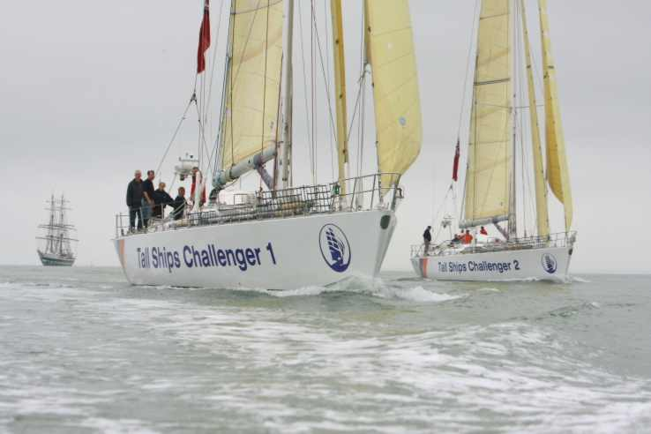Since retirement I have, what I tell my wife anyway, ‘worked’ in the sailing industry, undertaking skippered charters, corporate racing, instructing RYA practical and theory courses and a fine job it is! During the summer of 2008 I learnt that the Tall Ships Youth Trust were looking for qualified skippers for their newly acquired Challenger fleet, to act as ‘mates’ to assist the permanent salaried skippers. Following several months of paperwork, interview, CRB checks I was finally accepted.

The Tall Ships Youth Trust is the world's oldest and largest sail training organization. To date, the Trust's ships have sailed 1.5 million nautical miles with over 65,000 trainees on board. Over 4,000 trainees sail with the Tall Ships each year. The Trust's youth work is supported by the Department for Education and Skills. The Trust is the UK's largest single provider of RYA Competent Crew Certificates. Tall Ships Youth Trust voyages also qualify for the Duke of Edinburgh's Gold Award.

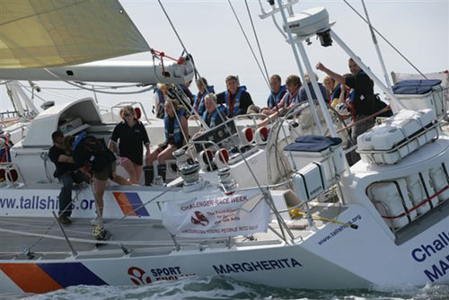The 72 ft, 50 tonne yachts are constructed of steel hulls and a sturdy rig that make them safe and solid. They are well designed, with a good lay out and are not intimidating for novice sailors. Down below is warm and cosy, plush saloon area and comfortable sleeping areas. Teamwork is required to sail the yacht – everything takes at least 2 people! The Challengers operate the highest level of safety procedures and all voyage crew undergo thorough safety training and vessel familiarisation before setting sail.

The Challenger fleet consists of 4 yachts divided into 2 fleets. One fleet operates around the UK whilst the second undertakes ocean passages visiting The Canaries, Azores, Atlantic Crossings including the ARC and the Caribbean. Qualified staff, whether salaried or volunteers consist of a skipper, mate, watch leaders and up to 14 crew. On the 17th February I flew out to Grenada for a 16 day trip through the Leeward and Windward Islands to Antigua.

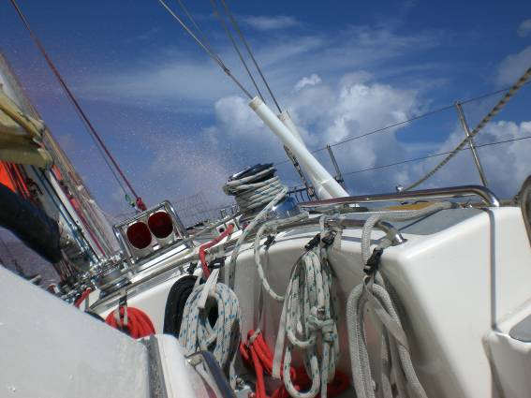Upon landing at Grenada it soon became apparent who was also joining the yacht with various sailing bags and jackets on display and a group of 6 young adults, together with another volunteer, Richard an accountant and yachtmaster from Glasgow. After a short taxi ride through Grenada we reached Port Louis Marina and joined Challenger 4 Margherita. Although about 6pm it was still about 30 degrees. Berths were allocated and bags stowed and after a brief tour of the yacht we adjourned to the bar to discuss the voyage.

Many of the younger crew had never sailed before and were completing Duke of Edinburgh awards or similar and the remainder had sailed various dinghies on lakes. This was going to be a big introduction to them to big boat sailing on open waters.

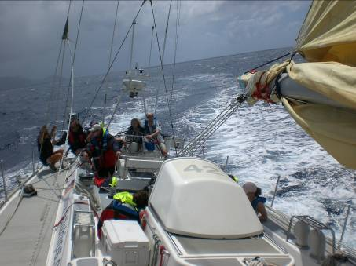Wednesday was taken up with becoming familiar with the yacht, showing the youngsters 'the ropes' and practicing head sail changes as neither of the two head sails were furling gear. Back to the old traditions of sail changes and considering the size and weight of the headsails, in the heat we had, this was going to be an exhausting exercise. Challenger 4 as well as having a fully battened main had a genoa, 3 yankees, stay sail and a storm sail, most of which we were to drag up from the forward sail locker hank on and use throughout the voyage. These head sails when correctly set typically held about a tonne and half of pressure with the main about 5 tonnes. As such all the running gear, ropes, clutches, dolly wheels, winches were all heavy duty equipment, far greater than the normal cruising kit we are normally used to. It did come to mind that they were probably just a bit more robust than Roger our late Commodore equipped ‘Caraul’ with!

The crew were divided between Richard and I into watches and after a morning of practice, drills, safety briefings and getting the yacht ready for an early start we had the afternoon off with a visit to Grenada’s main town Port Louis and a well deserved swim.

Thursday commenced with a wake up call at 0330 and shortly after 0430 we departed in the dark with an intended journey toward St Lucia. Although we had 11 days to visit the Windward and Leeward islands and reach Antigua, with the typical Caribbean weather patterns we were facing, all of the sailing was going to be beating with hopefully some reaching. The forecast was for dry sunny weather but with winds in excess of 30 knots. The main was hoisted with 3 reefs in and eventually the stay sail and No 3 yankee. I say toward St Lucia as the distance was about 130M and it was a case of seeing how the crew and weather progressed. With the temperature being 30 degrees and high humidity all tasks were very demanding. As the day progressed the intended journey was changed to head for the island of Bequia in the Grenadines, which was on route for an overnight anchorage. Winds were as predicted with an average of 30 knts and gusts over 36 which did little to disrupt the course of these yachts designed to race around the world the wrong way and through the roaring forties. So although it would have been pleasant to push on the young crew were wilting and we eventually reached Admiralty Bay Bequia at 1700 having covered 75M. Most of the meals were taken on board with a rota for cooking and cleaning up but at all stop overs we did manage to slip ashore for a few local rum punches and on this occasion a local steel band on the beach in the small village.

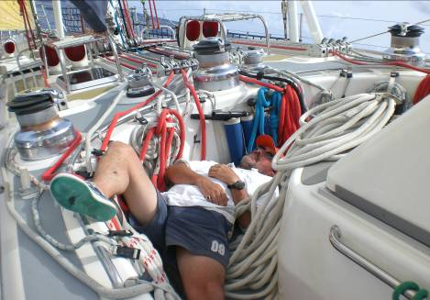***For some working in the ‘snake pit’ was just too much!!***

Friday was another early start with similar weather, the anchor was raised at 0700 and a similar sail plan was set to carry on north through the Grenadines. We passed Union Island, Carracou, St Vincent and Walliabou Bay where the Pirates of the Caribbean was filmed and part of the stage settings are still present. Crossing between the islands we had winds gusting over 40 knots and several of us had the task of dropping the stay sail and setting the storm stay sail and replacing the No 2 Yankee with the No 3, wet but totally pleasant in this warm climate. As we pushed on we passed several yachts but at one point you would have thought you were in the Solent. A windward catamaran flying the French flag was gradually dropping down towards us, and with on average 37 knots of wind, our boat speed of 12knts and 3-4 metre swells cut behind us with about a boat length to spare and despite our protests ignored us completely. Up to the island of St Lucia and eventually reaching Rodney Bay Marina on the top NW coast for about 1900. This was my third visit to this area and we berthed in what is now the super yacht marina which is to say the least impressive for the Caribbean.

Having covered a total of 150M in 2 days Saturday was a lay day with maintenance in the morning, swimming after lunch and a visit to the infamous Spinnakers bar and a meal ashore in the old town for those who know the area. Sunday the wind was forecast to ease a little. An early departure with an intended voyage to Casa Pilote a small anchorage on the west coast of Martinique. This was only a voyage of some 50M and we had large pods of dolphins escorting us at various times. Case Pilote was not over suitable from what appeared to be ashore and was also not that sheltered, so we pushed on for about 15M to St Pierre another anchorage slightly north. Here the water is some 200+ metres deep until about 10 metres from the shore when it suddenly changes to 1-2 metres so it is a case of dropping the hook on the top of the ledge and with suitable holding. Eventually this was achieved in a very picturesque location with the small town nearby and the ubiquitous Caribbean sunset.

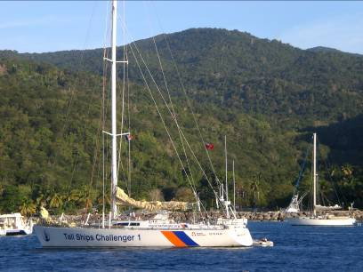Monday we raised the anchor at 0900 and with full main, staysail and No2 yankee departed for a short trip to Dominica which has 7 active volcanoes. The wind had eased to about 25knts and with a pleasant sail just off the wind reached the anchorage at Portsmouth about 1500. The small bay had several rusting hulks blown ashore by the tropical storms over the years and the village had 2 days of carnivals to celebrate the end of the slave trade. Their celebrations consist of loading up a lorry with every available speaker on the island and driving slowly around the town with volume at full blast and the locals dressed in fancy dress dancing in front, behind, underneath and around the lorry. A meal was taken ashore that night in the Purple Turtle which had been highly recommended by local boat people for its typical Caribbean cooking of crayfish and snappers. However I think the chef had been celebrating too much that day and I wouldn’t really rush to visit there again. The celebrations carried on through most of the night and as we departed heard that a local had been murdered during the night. Doyles Caribbean pilotage states 'security has now got better at this anchorage after local traders formed the Portsmouth Association of Yacht Security and several locals have been imprisoned' obviously they need to lock a few more up!!

Tuesday continued with our sail north, passing Iles de Saintes and on past the west coast of Guadeloupe, with 18knts of wind from the ESE. Guadeloupe we learnt in Portsmouth had been having 30 days of riots from discontent and we were told that the locals were angry and tense with little food or shops open on the island and it was not a place to venture ashore. We made our way to the top of the island and a small anchorage called Deshaies north of the Grand Terre. This area is very lush, sugar cane is produced here and picturesque wind mills are now replaced in some cases by wind farms. Deshaies is a small fishing village surrounded by mountains which channel the wind down from the rest of the island into the anchorage making it quite fierce and howling at times. Again the pilotage book describes it as more like to the roaring forties than the picturesque French department that it is. Several of us ventured ashore to see what fresh supplies if any we could locate and were pleased to find that our first offer of assistance was a local bar which was open and more than friendly for a beer or two. Many of the buildings were daubed in protest graffiti and we learnt that the 250 French police bought over from Europe to quell the disturbances had only just left!

We departed the following morning about 0800 from Deshaies and a fine reach with ENE winds of 22knts towards Antigua with Montserrat and another active volcano to our west. We cruised along at 10 knots with full main, staysail and Number 1 yankee up, past Pigeon Island and the Cousteau underwater centre to Falmouth Harbour Antigua, a distance of 45M, where we moored amongst some pretty impressive several million pound yachts. It is only when you get amongst some of these vessels that you then realise that a 72ft 52 tonner is not that grand compared to these yachts.

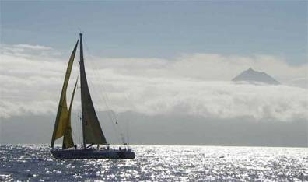These yachts are no different to sail in principle to others, it’s the size and power that is vastly different. The main issue with these yachts is getting to know the below deck procedures for fuelling the 4 tanks, 4 water supply tanks, day fuel tanks, grey tanks and where all the stop cocks, switches, generators water makers etc all operate from. Also most yachts over 40ft have the luxury of bow thrusters, not on these monsters as they were not designed for much manoeuvring in confined areas so they are beasts to turn around in small areas. You have to be, and soon do get, fit working in the 'snake pit' the area of winches, clutches and ropes in front of the cock pit which takes 3 people to pull, push, winch, grunt, groan and moan when you have been allocated to it. The young adult crew members were great workers, enthusiastic and good fun to be with.

The two Challengers are due back in May to the UK where they join the other two for summer sailing around the UK. In the autumn two will again complete in the ARC and remain in the Caribbean for the winter circuit. So an excellent trip and looking forward to more on these yachts with perhaps some racing next autumn back out in the Caribbean.

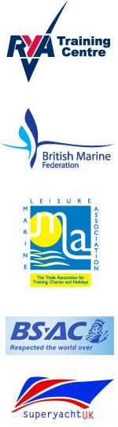fl00128_[1]**Training or Cross Channel Opportunity**

The week of October 26th to 30th has been identified as the only available week for both the SPOSC Cross Channel Venture and the training week being run by our Treasurer and Resident Instructor, Alwyn Evans. This is a great opportunity for those wishing to visit foreign shores and for those hoping to improve their sailing techniques and perhaps gain a RYA qualification.

Please note that these voyages are totally separate and those undertaking training will not find themselves in France unless the GPS is seriously faulty or Alwyn’s wine cellar is depleted!

**SPOSC AND LOCAL CHARITIES**



**By Terry Clothier**

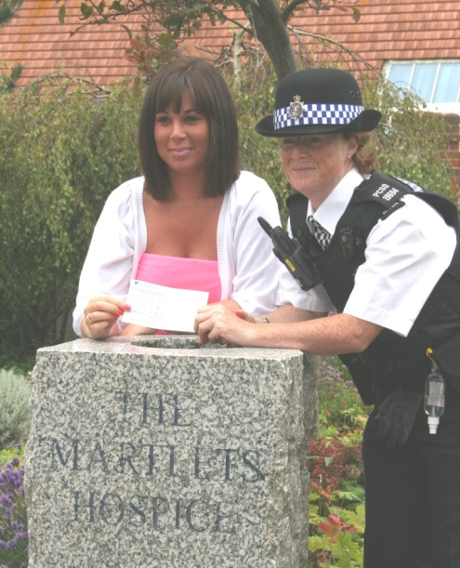

The Sussex Police Offshore Sailing Club has for some time supported the Royal National Lifeboat Institute and for each day sailed by members £1 of the fee paid goes to that worthy charity. I am sure that should you ever be in the unfortunate position of needing their services you would consider it money very well spent. Indeed on the first day of the 2009 PSUK National Sailing Championships a helicopter lifted an injured crew member from the deck of the GMP boat and rushed him to hospital. Luckily he was not seriously injured, but the efficiency of the service gives one the best possible chance of surviving a disaster and certainly provides a sense of security while sailing in UK waters.

***SPOSC Vice Chair Freya Carter presents a cheque to Gemma of the Martlets Hospice, Brighton***

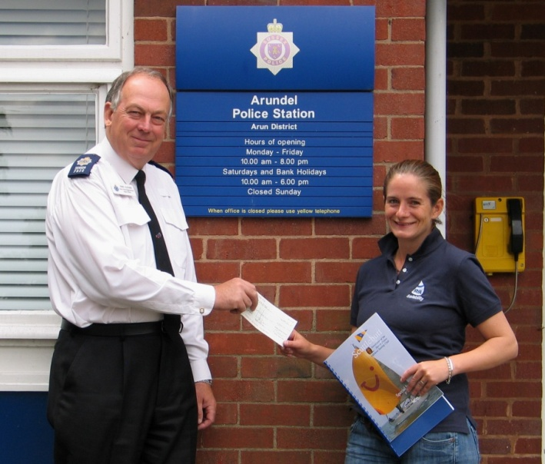In addition to our support for the RNLI, during the PSUK 2009, hosted by Sussex we chose to support two other very worthwhile causes. Our first charity was The Martlets Hospice, Brighton, as suggested by our event photographer Kevin Claxton, who since retirement from the Force has worked for the NHS and sees first hand the splendid work they do. The sale of teddy bears supplied by the charity raised £132 in a very short time. The second charity, RYA Sailability, which seeks to enable those who feel they are unable to even get on a boat, let alone sail it, the chance to have a go, seemed a most appropriate choice

A raffle held during the Formal Dinner, on the Thursday of the event, had some fantastic prizes provided largely by some very generous benefactors, including Commodore Yachting, Team Sailing and Ring Powercraft as well as local Author and Director Peter James. This raised a further £1,000 which was duly and equally divided between the two charities at separate ceremonies as pictured.

***Morna Hughes of RYA Sailability receives a cheque from SPOSC Commodore Terry Clothier***



Alwyn Evans received this certificate on behalf of the SPOSC in March of this year.

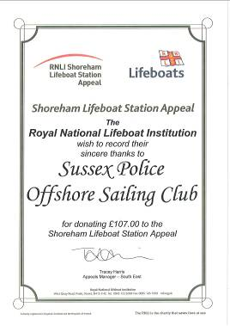

**CYPRUS HOLIDAY OFFER**

**From Julie & Kevin Claxton**

**2 Bedroom and Studio Apartments in 5 Star Resort Peyia, Paphos, Cyprus**

**New Apartments minutes from Coral Bay  
5 Star Resort Ideally Situated, Pools, Leisure Complex, Large Terraces and Parking**

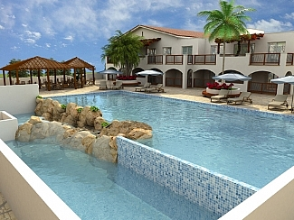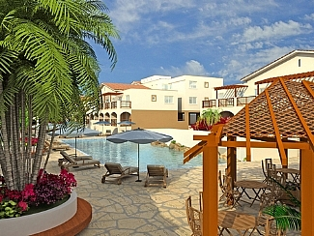**The Vanessa Apartment complex in** Peyia is brand new and we are now taking bookings for this 5 star resort. The studio is on the 1st floor and the 2-bed on the 2nd (upper) floor with lovely views to mountains. The complex is close to the centre of the delightful traditional village of Peyia. Within a short walk are a choice of bakers butchers and supermarkets, as well as restaurants and bars. Communal facilities in this brand new complex include: large swimming pool, heated indoor pool, indoor and outdoor Jacuzzi, pool bar, changing rooms, sauna and gym with landscaped gardens. The property includes private parking space, visitor parking and a large terrace. Tastefully furnished and well equipped, the apartments are only five minutes drive from Coral Bay, renowned as being one of the best beaches on the island. Also nearby is the famous Akamos peninsular with its protected parkland. It is just 20 minutes from Paphos Centre, with its culture, history, port, and abundance of shops, bars and restaurants.

For further information follow the link to; <http://www.ownersdirect.co.uk/cyprus/cy2230.htm>

Or Contact; Mr Kevin and Mrs Julie Claxton  
Tel: (UK) + 44 (0)1273 581 879  
Mob: (UK) + 44 (0)7856 917 007 ***Discount is offered to SPOSC Members!***

**Editorial Note**

Please remember that this is your magazine and should reflect your views and experiences for the benefit of other members. If you have any comment, articles or photographs you feel are appropriate for inclusion then please forward them to me [terryclothier@hotmail.com](mailto:terryclothier@hotmail.com) for publication.

*The opinions expressed in articles within Scuttlebutt are those of the individual only and not necessarily those of the Sussex Police Offshore Sailing Club. No responsibility can be accepted for any inaccuracies or omissions.*