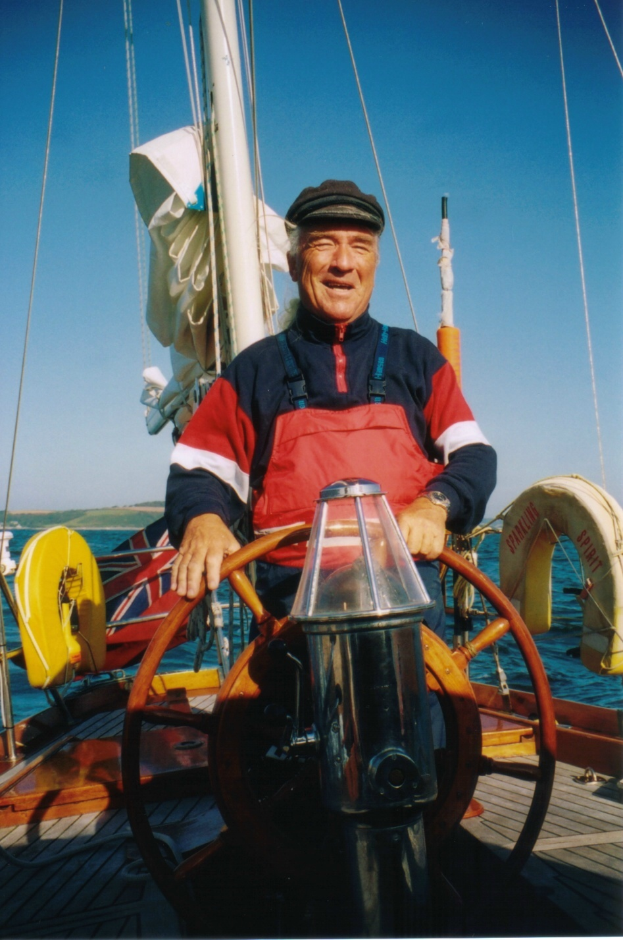j0343921Scuttlebutt

*Newsletter of the*

*Sussex Police*

*Offshore Sailing Club*



Issue 162

June 2009

Scuttlebutt No. 162

June edition 2009

********************************************

**CONTENTS**

1. **The Frostbite Charter 2009**
2. **The PSUK Support Boat story**
3. **The PSUK 2009 Dinghy Championship**
4. **The Owners Rally 2009**
5. **Cross Channel Trip 2009**

******************************************

COMMITTEE

Senior Flag Officer Commodore – Terry Clothier

##### OFFICERS OF THE CLUB

Chairman……………… Steve Rigby

Vice Chair……………. Freya Carter

Sec…………………… Julia Beckett

Treasurer……………… Alwyn Evans

Assistant Treasurer …… Jonathan Lelliott

## Asst. Sec and Membership Donna Powell

******************************************

### REPRESENTATIVES

**West Downs** - Gill Hooton

**Brighton & Hove** Lindsey Valder-Davis

**North Downs** - Alan Haffenden

**East Sussex** - Donna Powell

**HQ** - Kevin Wallis

**Sussex House** - Martin Cheesman

**Gatwick -** Mark Osborn

******************************************

SCUTTLEBUTT

Editor ……………………… Terry Clothier [terryclothier@hotmail.com](mailto:terryclothier@hotmail.com)

Mediterranean Correspondent… John Sumner [johnsumner@wanadoo.fr](mailto:johnsumner@wanadoo.fr)

Caribbean Correspondent … Peter Kennett [peterkennett3@aol.com](mailto:peterkennett3@aol.com)

USA & Pacific Rim Correspondent Mark Hayler [vossen26@bellsouth.net](mailto:vossen26@bellsouth.net)

**Cover Photo – Lenny Wheeler at the helm of Sparkling Spirit by Emma Clothier**

**STOP PRESS**

Sussex Police Offshore Sailing Club now has its own website, thanks to our own Webmaster, Dusty Miller. Log on to <http://sposc.weebly.com> check out the site, have your say, advertise gear for sale and even read Scuttlebutt.

**Club Frostbite Charter Sunday 15th – Friday 20th March 2009**

**by Alwyn Evans**

The club ‘Frostbite’ charter took place from Sunday 15th to Friday 20th March 2009 with a Bavaria 37 chartered from Fairview Sailing Port Hamble Marina. The ‘A’ team consisted of 6 members, Chris Gillings, Richard Smith, Phil Mears, Chris Sparkes, Pete Ewen and Alwyn Evans from Sunday evening until Wednesday morning and the ‘B’ team, Frank Hooper with Juliet Fowler, Dave Cherry, Ron Nevitt and Kevin Claxton from Wednesday until the end of the week. This charter gave many newly qualified day skippers the opportunity to practice their skippering techniques, get behind the wheel and renew their ‘parking skills!’

The ‘A’ team arrived at 1730 Sunday evening and Fairview had ‘upgraded’ us to an Elan 434 *Impression.* This yacht, ‘White Orca’ was somewhat of a difference to the Bavaria with double forward cabin, cabin and 2 bunks, 2 double rear cabins and a spacious saloon complete with TV. She certainly had a mean look about her with a high freeboard, double wheels and black sweeping saloon windows giving her a go fast appearance. The paperwork revealed a purchase price 12 months ago of nearly 200,000 pounds! Needed to watch out for scratching here on pontoon bashing! After the usual stowage of gear and completion of inventory a trip to the Hamble village hostelries was made prior to a reasonably early night for an early start the next day.

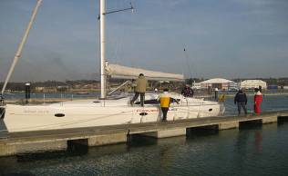

The forecast for the next few days was sunny weather, light winds ranging from westerlies to north and easterly as the week went on. Monday morning brought a thick fog, so following the completion of a hearty breakfast at 8.30am and with the sun burning the fog away we made our way out of the Hamble and into Southampton water. The intention was to make to Poole. An attempt was made at sailing in light winds against the tide which we hoped would turn west by midday. We finally gave in to the lack of wind and fired up the engine to take us to Newtown Creek for lunch.

***Frostbite crew moor ‘White Orca’ at Cowes***

At 1330 we set the sails to take us out of Newtown and west down the Solent. Although bright and sunny with a SOG of only 3.3 knots the engine was summoned again and we took the afternoon tide out through Hurst and the North Channel to Christchurch Bay. The wind was light all afternoon but cold and with a flat sea and a strong favourable tide we still managed SOG of over 9 knots and reached the Poole entrance buoys about 1630 and into the Marina at the Town Quay by 1730. Following a meal aboard, a tour of the local hostelries was made where all appeared to be suffering from the economical down turn or the fact it was a cool frosty evening in March!

In order to make the most of the west going tide on the Tuesday, an early breakfast was taken and by 0815 we had departed the mooring to make our way down to the entrance. Again the weather was sunny but luckily no fog. We managed to swerve around the Sandbanks ferry. Wind was somewhat lacking and we motored out through the main channel towards Old Harry and then turning west. Tide was again favorable and after about half an hour the breeze freshened from the north east, sails were set and it was not long before we had a steady 15-17 knots of consistent breeze.

The Fairway buoy was reached within a couple of hours and we completed a series of tacks to take us past the Needles, Alum Bay, through Hurst narrows and into the western Solent. We managed to maintain a steady 7-9 knots over the ground and continued to tack up the Solent before the tide turned against us off Beaulieu entrance. Although the wind eased and we were battling against the ebbing tide, being purists, we continued with some long tacks to take us up towards the Bramble Bank, making our last tack at 16.30 to take us to the Cowes entrance. Sails were dropped in an expert and seamanlike manner and we eventually parked ourselves in the Cowes Yacht Haven for the night. A few other school boats were present but other than these stalwarts again the marina and town were quite quiet even though it was St Patrick’s day.

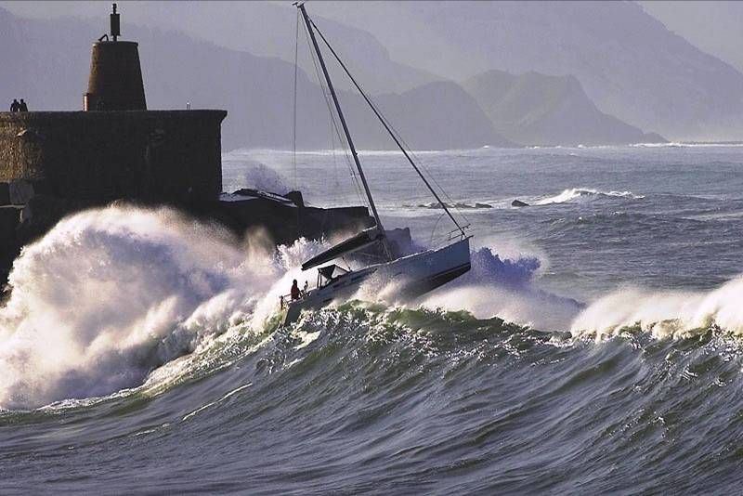Following an early breakfast ashore on the Wednesday morning we departed at 0845 to make for the Hamble. With the fresh easterly breeze, bright sunshine and an east running tide we enjoyed a brisk beam reach across to Southampton water before the breeze dropped near to the Hamble river entrance. A total of 65 miles covered with everyone enjoying some good weather, good sailing, good company and good food.

***Frostbite crew leave a Solent Harbour!***

‘White Orca’ was parked back at her berth in Port Hamble Marina and the ‘B’ team was present and eager to get sorted aboard. It was not long before we waved them good bye as they departed westwards for a similar voyage of discovery!!

**PSUK – The Support Boat Story – 2009**

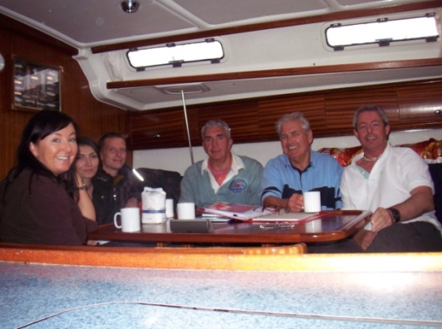**By Paul ‘Dusty’ Miller**

Yacht ‘Adelaide Star’ a Bavaria 44 was once again the ‘support boat’ for the Sussex Race Team competing in the 2009 PSUK Offshore Championships. The difference this year was that Sussex Police Offshore Sailing Club were the hosts and organisers of this year’s event.

‘Adelaide Star’ was chartered from Commodore Yachting based at Gosport Marina where on the Sunday afternoon the skipper Dusty Miller and crew of Ron Nevitt, Don & Elina Sellings, Owen Poplett and Tara McDonnell all met up. Ron and Owen had undertaken the provisioning of the yacht whilst Dusty Miller had earlier been dropped off at the Marina from the Sussex Police Sunsail Yacht 36 which had been out for a weekends training session with the Sussex Race Boat.

***The Adelaide Star crew***

Once the skipper and crew became reacquainted with the yacht and all provisions stowed away it was off to the nearby Pub for a meal and to get to know each other.

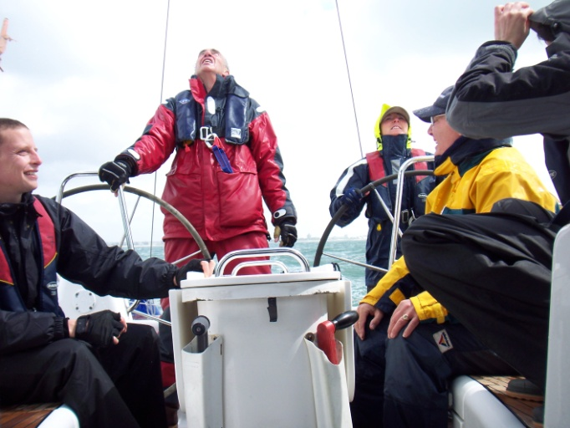The following morning Monday 18th May we meet up with the Sussex Race boat and crew provided them with their breakfast and lunch bags and we prepared to go off sailing.

With a forecast of 5 to 7 with a SSW wind it lived up to expectations and we motored into the wind, waves and rain. Come lunch time the weather abated and following lunch in Osborne Bay it was sails up and into an amount of good winds and enjoyable sailing with the new crew coming to terms with the yacht and conditions. A really blowy and soggy day and we were happy to get into Cowes Yacht Haven come late afternoon.

***First day damp and wet   
but loads of fun***

The following day with a more favourable forecast of 4 to 5 occasional 6 with showers we were out of Cowes by 9.15 heading west with the sails up towards the needles. We did find all the showers and the Force 6 taking refuge in Lymington for lunch. The rain cleared up and it was sailing all afternoon in really good winds which blew us back to Cowes in double quick time. That evening Owen left us. He gained a lift in the Hampshire Police Rib which had two 300 horse power engines that took him back to Gosport at an extremely fast speed which by all accounts was a fantastic but bumpy ride.

Wednesday the weather was fine and winds of 3 to 4 ideal for the novice sailors aboard. The Race fleet had been away early to undertake the Round the Island Race. We sailed up Southampton Water right up to the liner basin and then back down up the Hamble where we had lunch at the Town Quay. We returned to the Cowes area continuing the sail training of the crew.

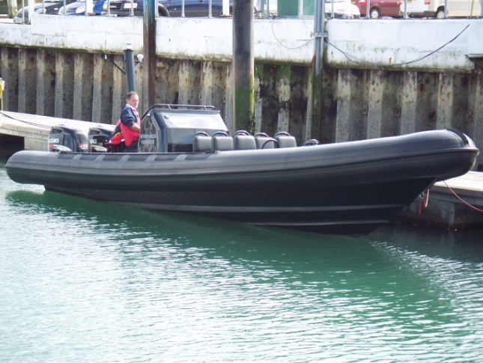Thursday morning saw Andy join the crew following his fast delivery from Gosport by the high speed rib. It was a lovely sun tanning morning and we were out of Cowes early heading firstly up wind sailing till we reached the Beaulieu entrance and then turning downwind to join the Race fleet that were racing off the Bramble Bank. We joined the fleet who were racing with their spinnakers filled a great sight and subsequently we anchored for lunch. The Race fleet started a further race and were quickly off into the distance and we sailed via Osborne Bay into the Medina and onwards to the mooring pontoon at The Folly Inn. We had a fantastic evening, great meal and the whole of the Sussex contingent returned to Adelaide Star to use up the surplus food and onboard drink where the party continued into the early hours.

***The Rib providing   
transport that went faster than the spray***

The following morning all rather worse the wear we went down the Medina. It was a beautiful morning and were soon out into the Solent realising that this was Friday our last day all wanting to gain as much as possible from the day. We were soon with the tide and wind off Portsmouth where Tara and then Don took charge and put the yacht through numerous manoeuvres with chilling control and well founded confidence. We returned to Gosport Marina and were soon joined by the Sussex Race boat who took Elina, Don and Tara back to the presentation ceremony at Port Solent leaving Any Ron and Dusty to continue cleaning up the yacht and joining them later.

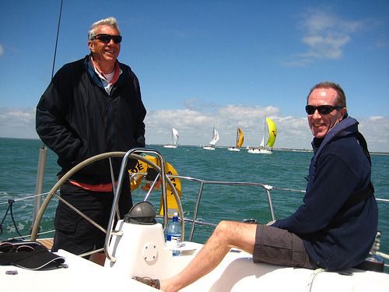

***A happy skipper and crew***

The crew of Adelaide Star undertook their role of supporting the Sussex Race boat with a passion ensuring that every morning breakfast was prepared plus their lunch bags seeking to comply with all requirements. In addition we were supplying the Race Committee boat crew also with breakfast and lunch and on occasion our official photographer. The evening meals were something to behold, bearing in mind the cooking facilities available, the crew produced meals often for over twenty people per night to an extremely high standard. The Race Officer was truly impressed with the variety and complexity of each meal that were in his view of a standard that rivalled any Cowes top restaurant!

In summary it was as Ron pointed out the best sailing week and event for many years having ideal weather conditions the winds being fantastic and most days being warm and sunny providing us with a top notch sailing week.

**Police Sport UK  
National Dinghy Sailing Championships, 2009**

**by Paul ‘Dusty’ Miller**

**Wednesday/Thursday, 10-11th June, 2009**

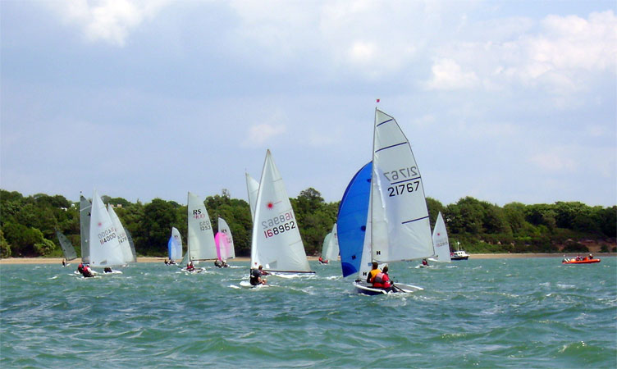

At the 2009 PSUK national dinghy championships 27 boats took part at Netley Sailing Club on the banks of Southampton water in perfect conditions - Not too calm, not too windy. The racing amongst the main competitors was close and albeit the boats varied from an RS700 to a Europe, there was plenty of competitive spirit throughout the fleet.

The Sussex competitors were Bob Trevis in the Sussex Police owned Laser, Mike Scrivener in his new Contender and Dusty Miller and Freya Carter in an RS400

Day One of the Dinghy Championship dawned damp and grey. All 27 boats made the start for Race One. Boats got away well enough despite two boats caught being over the line at the start. As the wind blew, there were a few capsizes including the RS400 with Dusty and Freya getting completely immersed and retiring from that race. Bob and Mike finished a creditable 13th and 14th

After lunch, Races Two & Three were held back-to-back. The wind, which had been so lively in the morning, decided to settle somewhat and as the general commercial traffic of the deep-water channel sent waves across the course, the shorter length boats were bound to suffer whereas the faster dinghies were able to carve their way through the lumpy conditions. Bob Trevis was consistent throughout the day remaining in mid fleet position.

Day Two and conditions were bright and breezy first thing but the wind never really rose as forecast. Nevertheless, conditions were excellent with good winds to start in bright sunshine. The two races were sailed back-to-back.

Race Four. A bit of a muddled start as the line plus with a good wind with some gusts it caught out the odd boat including some gear failures. Mike Scrivener found trouble aboard his Contender and had to retire. Dusty and Freya had their best race of the event coming 15th in the fleet.

In race Four and Five Bob continued to sail well ensuring that he had a result in the top half of the fleet coming in 9th in each race. Halfway through the race the wind changed direction and boats were racing down the third leg on a different tack. The fleet just managed to get ashore before the weather changed completely and the heavens opened.

Simon Hawkes representing Avon & Somerset Police in a Phantom is this year's champion

Trophies and Prizes were presented by Dick Fedorcio - Director of Public Affairs Metropolitan Police Service who is member of the Metropolitan Police Sailing Club.

The Principal Race Officer was Dave Nicholls who is an RYA Race Officer and serving police officer in Metropolitan Police.

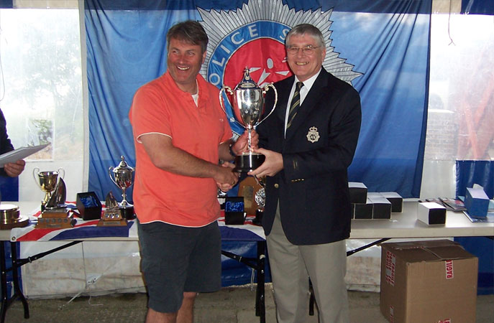

**Bob Trevis   
receiving the   
Maiden Cup**

The final positions resulted in Bob Trevis the highest placed Sussex boat at 12th and winning the Maiden Trophy being the highest placed sailor who had not previously won a PSUK Trophy, followed by Dusty Miller and Freya Carter at 18th an excellent result bearing in mind that Freya had limited experience in the RS 400 followed by Mike Scrivener at 23rd who had been dogged with a number of problems but still well off the bottom places.

Dinghy sailing is available to all Sussex Police and details can be found via the intranet or at <http://spdsc.weebly.com/>. If interested to join or would like a Taster sail please make contact with us via the website. You will be made very welcome and we can cater for all levels experience

**The Owners Rally 2009**

**by Frank Hooper**

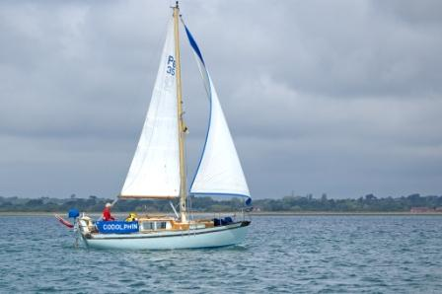Traditionally the Rally has always taken place around the 20th June, so it was with fingers crossed that the weather would behave itself that the participating boats made their way towards the Solent for the scheduled start on 8th June.

Four member’s boats, together with the Club charter, made up the fleet, not as good as we have done in previous years but nevertheless a creditable turnout. As usual our Commodore was crewed with Lenny Wheeler on ‘Godolphin’, he must be some sort of masochist to keep coming back for more. Graham Castell had brought ‘Ruby Tuesday’ up from Eastbourne with his co-owner Mick and Stuart Roberts, and had a more pleasurable trip along the coast than when coming up for the PSUK week. That regular attendee Mick Tagg and Graham brought ‘Oh Deer’ and to complete the fleet belatedly came Peter and Christine Harrison, Brian and Gill Sole, Alwyn and Pauline Evans aboard ’Flyer’. I say belatedly, as it took them two days to get from Chichester to The Folly, with some excuse about open bottles of wine having interrupted the passage in Portsmouth Harbour. By the time the above assembly had ventured into the Solent, the Club boat, a Beneteau 37 from Fairview, courtesy of our Treasurer, was already out and in Weymouth. In addition to those regulars Ron Nevitt and Chris Sparkes, we had two new crew in Trevor Hinkley and Beverley Lucas.

***Godolphin under sail***

Because the Club boat was on charter from the evening of Sunday 7th June it seemed a pity to waste charter time in the Solent as we were not meeting the other boats until Monday/Tuesday, and in ’Flyer’s’ case Thursday. As the weather was kind - no wind- and it was full moon, we opted to take a run down to Weymouth, leaving on the Sunday night for an overnight passage to arrive in Weymouth for opening time on Monday. I am not sure that Trevor appreciated this move as he was unfortunately taken with a severe case of ‘mal de mer’ which tended to confine his activities to the heads. The rest of us had a pleasant motor out of the Solent with the tide and west toward Portland Bill. The wind finally arrived around 4 am and the rag was hoisted for an enjoyable sail into Weymouth Bay where we berthed on the Customs Quay after a slight delay whilst awaiting the departure of another yacht to secure an alongside berth. Unfortunately the pubs were not open as we were too early having miscalculated the strength of the tide. Trevor, after one final heave as we berthed, came back to life and breakfast was produced prior to a little bit of bulkhead surveying (sleeping to the uninitiated).

A discussion with ‘Godolphin’ confirmed that they and ‘Oh Deer’ were heading for Yarmouth and we agreed to meet in Poole on Tuesday evening. The delights of Weymouth were sampled during the remainder of the day. I can thoroughly recommend the local beer called ‘Steam’ but not much else. That evening we found ourselves rafted inboard of no fewer than four other boats, there being a Halberg Rassy rally passing through, plus numerous others. Having announced our intention to depart at 9 am the next day we left them to make of it what they willed.

Tuesday morning dawned - Ron makes sure we see the dawn on the Club boat- bright with a reasonable wind off the land but still with that chill in the air that marked the whole week. It was sufficiently breezy to put a couple of reefs in the main and roll some headsail before we ventured out of the harbour. The engine went off as soon as we cleared the pier head and set course to avoid the overfalls off St Alban’s Head and managed to sail almost to Old Harry Rocks before a combination of contrary tide and falling wind forced recourse to the iron sail. As we motored up the fairway ’Godolphin’ could be seen coming through the inner channel and we overtook ‘Oh Deer’ about half a mile from the Chain Ferry. Finally all berthed in Poole Haven marina where ‘Ruby Tuesday’ was already taking a liquid break. I must report that at this stage our Commodore did not sound or look too well as he appeared to be suffering from swine flu or overwork from organising the PSUK. Two days with Lenny can’t have helped. I felt much the same when I discovered that the marina wanted £40 for the privilege of parking on their bit of sea (NB: Poole is off the itinerary in future).

It being Tuesday, we were all treated to the usual gathering of motorcycles on the quay, I can’t repeat what Chris had to say about his fellow bikers but it wasn’t complimentary. In lieu of anything better to do, we all repaired to the Wetherspoons across the road where Graham had spotted a fantastic bargain - or so he told us- whereby we got a pint of something free with food. At some stage in the evening it was agreed that as it was Wednesday the next day, it must be Lymington which meant that the tide dictated an arrival at the Hurst Narrows not much later than noon.

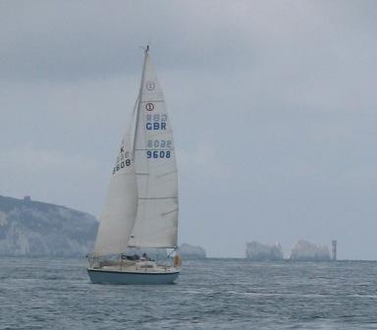By 7am the next morning there was much activity on the pontoon and even some people going for a shower. ’Godolphin’ and ’Oh Deer’ exited first followed by the Club boat and finally ’Ruby Tuesday’. All, except Graham, choose the inner channel to save time and a steady breeze from the SW gave us a fine sail towards Hurst. Messrs. Wheeler and Tagg were off at a gallop and we all reached Hurst with time to spare. We opted to sail up to Cowes with the tide while the others entered Lymington to secure places at the Town Quay - a wise move. Our arrival at about 4 pm completed the assembly with ‘Godolphin’ and ‘Oh Deer’ rafted while we came alongside ‘Ruby Tuesday’. As usual the Quay soon filled up and we had a Golden Hinde for a neighbour.

***‘Oh Deer’ at the Needles***

For some of us the main objective was to find a hostelry that had a television which was going to show the British Lions game. Diligent enquiries revealed that the only game in town was the pub adjacent to the Railway Station which didn’t open until 6 causing much consternation as the game started at 6. However all was resolved, the publican who wanted to have the cricket on was prevailed upon to see the light ( it helped that the cricket was rained off). Unfortunately said pub did not include food in it’s list of features, and as there were those present who wanted to see the England v Andorra game which followed shortly after the end of the rugby, there was an undignified rush to the nearest chippie to re-fuel before returning to the bar. The publican must have thought it was Christmas again as practically the whole rally gathered in his pub, making it his busiest evening for a long time. At some time during the day contact had been made with ‘Flyer’ who promised to try and get to The Folly for Thursday evening assuming they could drag themselves away from the delights of Portsmouth, or perhaps the wine.

Thursday brought us similar weather to the rest of the week, dry mainly sunny but with a chilly breeze which gradually increased as the day worn on justifying the Met Office forecast of SW Force 3-4-5-6 ( covers all eventualities ). ‘Oh Deer’ was first away followed by ‘Godolphin’ with the Commodore looking and sounding better. After assisting the Golden Hinde alongside the quay the Club boat departed with the express intention of heading directly to The Folly. As a consequence Graham invited Trevor and Beverley aboard ‘Ruby’ for a trip up Southampton Water, while the 3 grumpy old men dawdled along the Solent under headsail in the Club boat. Utilising his excellent contacts with The Folly, and also wishing to make amends for the disappearance of numerous wine glasses at the PSUK final ‘do’ from The Folly, (probably the Met), Terry arranged for the Rally to berth at the Folly pontoon, thus avoiding the cost of the ferry and the likelihood that we would be ‘persona non grata’ after G. Randle’s efforts last year with a certain ferry lady.

Thus it came to pass that at about 5 pm that day the complete Rally came together in one place, ‘Flyer’ having managed to make it across the Solent, and it was with considerable pleasure that we were able to fend off various others intent upon berthing alongside, although somehow a Met Police S.C. boat ended up alongside ‘Flyer’ - I hope they checked their wine glasses the next morning. A convivial evening was spent in the afore mentioned establishment with some ‘afters’ aboard ‘Flyer’ as they wanted to get rid of some Metaxa brandy (only too happy to oblige).

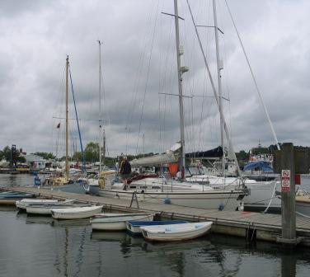Friday morning soon came, and with it the dispersal, ‘Ruby Tuesday’ away first en route to Eastbourne, followed by the Club boat, which scraped along the river bottom for the first half mile owing to a rather low tide and our need to be back in the Hamble by 11 am. The others were left to depart at leisure and with more water, and some are probably still there! Readers will note that there has not been much discussion of the finer points of sailing. Dictates of wind, tide and berthing tended to restrict the opportunity to hoist the canvas, and in any case the main purpose of the Rally is social with the sailing ancillary to the event, and I think we succeeded in our purpose. Those who want to do some sailing should sign up for the Passage Trip at the end of October.

***The fleet in Lymington***

Frank Hooper

June 2009

**Cross Channel Venture**

j0297741Please take note that the Cross Channel voyage is now planned to take place between Monday 26th and Friday 30th October, 2009 so as not to conflict with Sussex Police commitments during September. There has already been a great deal of interest shown in this trip so if you wish to apply for a place please contact Julia Beckett soon. This is later than we would normally plan this event, but has to avoid the Met Race Series and Alwyn’s training course. In the event of weather being inappropriate to ‘go foreign’ a coastal voyage would be a considered alternative.

**Editorial Note**

Please remember that this is your magazine and should reflect your views and experiences for the benefit of other members. If you have any comment, articles or photographs you feel are appropriate for inclusion then please forward them to me [terryclothier@hotmail.com](mailto:terryclothier@hotmail.com) for publication.

*The opinions expressed in articles within Scuttlebutt are those of the individual only and not necessarily those of the Sussex Police Offshore Sailing Club. No responsibility can be accepted for any inaccuracies or omissions.*