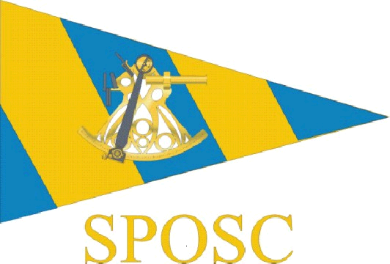

Sussex Police Offshore Sailing Club
Sussex Yacht Club
Shoreham
1830 hours Monday 25th February 2013

Committee Meeting - Minutes

The meeting was opened by Steve Rigby (Chair) at 1840 hours.

Those present; Steve Rigby (Chair)
Dave Frey (Secretary)
Freya Carter (Vice Chair)
Alwyn Evans (Treasurer)
Terry Clothier (Commodore)
Dusty Miller (Webmaster)
Anne Darling (Brighton & Hove rep)
Julia Beckett (HQ rep)

- Apologies received from Owen Poplett, Alan Haffenden, Kevin Wallis

- The minutes of the previous meeting were agreed and there were no matters arising

- Race Treasurer & Assistant positions
DF stated that the current situation for cruising and racing parts of SPOSC were financially separated with accounts for each. AE runs the Cruising account, assisted by FC. DF runs the Racing account as an informal arrangement that started around the time of PSUK 2009 organisation. The committee agreed the position should be formalised and an assistant appointed (signatory). DF stated he was willing to continue and JB agreed to become Assistant Race Treasurer and signatory.

- Committee members
SPOSC committee membership was discussed and the following was proposed to put forward to the AGM
Chair Steve Rigby
Vice Chair Freya Carter
Secretary Dave Frey
Treasurer (Cruising) Alwyn Evans
Ass Treasurer (Crusing) Freya Carter
Treasurer (Racing) Dave Frey
Ass Treasurer (Racing) Julia Beckett
Webmaster Dusty Miller
Membership Secretary Owen Poplett

Terry Clothier stated that he felt it was time for him to stand down as Commodore after a number of years. SR accepted this and thanked TC for all his work over the years on behalf of SPOSC. SR also proposed the DM be nominated as Commodore and this was agreed by the meeting.

- Area reps were discussed and the following agreed
Brighton & Hove rep Anne Darling
West Sussex & Gatwick rep Alan Haffenden
Sussex House rep Owen Poplett
HQ rep Julia Beckett

There was discussion about the East Sussex rep. Kev Wallis is no longer working in the organisation and therefore unable to continue. There was a nomination from DM but that person would need to be spoken to. (See AGM minutes)

- Programme of events 2013 and responsible persons
SPOSC will run
Frostbite (March 2013) Owen Poplett
PSUK race Steve Rigby
PSUK support Dusty Miller
Owners rally Lenny Wheeler
Long Passage (vacant - see below)
Met Open race Steve Rigby

AE disclosed that Frank Hooper, who normally organises the Long Passage cruise, was not available this year and would talk about this at the AGM.
AE also stated that he had discussions with Dave Gaylor (SPSA). An additional grant of £500 (five hundred pounds) could be available to SPOSC to run a second boat for the Met Open, or a training boat. Ideas to be discussed outside of this meeting.

- Training
Discussion around how SPOSC could offer training through TC and AE (via other RYA approved centres). DF stated that members would like opportunities and asked if SPOSC could facilitate arrangements. AE stated the issue was around arranging courses in advance. Both AE and TC were willing to accept applications. Their courses could be advertised on the website.
Action - DF to email membership to ascertain what the appetite is for courses.

- Trophies
Club trophies were discussed. As a reminder trophies are awarded as follows;
  - Commodore’s Shield major achievement in sailing
  - Roger Dice major contribution to the club
  - Scuttlebutt best member’s article published
  - Portobello Cup RYA achievement award

A discussion and nominations followed and the following was agreed;
- Commodore’s Shield Steve Rigby as new organiser of Gurney Fund sailing
- Roger Dice Terry Clothier for contribution to SPOSC over time
- Scuttlebutt Anne Darling for her Frostbite 2012 write-up
- Portobello Cup Alwyn Evans for his continuing training of others

- Payments, account, and booking
AE stated that he was updating the cruising account for internet banking. DF will be doing the racing account also.
AE stated that daily rates for cruising had been static for some years and we should consider an increase. There was discussion about this, including the fact that ‘racing’ contributions had risen from £20 per day to £25 per day a couple of years earlier. It was agreed that the ‘cruising’ contributions would increase to match. DM said that Frostbite participants had already paid £20 per day. He suggested the increase apply from 1st April 2013, so the increase would apply to all events from then, including PSUK 2013 support boat.
AE also stated that the booking of charter yachts could become an issue as deposits or full payment was often required before members had committed to an event and paid fees. It was agreed that future events would have to be financed by fees prior to any charter bookings (other than provisional). DM outlined that there was the need for an earlier commitment by this Committee to nominate Skippers who decide the dates (according to Tides) and then arranges publication to attract the crew. It would be appropriate that at the Committee meeting well before Christmas that the next years charters and events are subject to an Agenda item as regards dates and Skippers.

- Booking procedures - dealt with at 9.

- AOB
There was no other business

- Date of next meeting
DF asked if the normal pre-Christmas meeting was at the right time of year, being very close to this meeting and the AGM and not allowing proper early discussion of events etc for the next season. It was agreed that the Committee should aim to meet in late summer rather than late autumn.
Action - Date to be arranged by DF.

The meeting was closed by SR at 1920 hours

