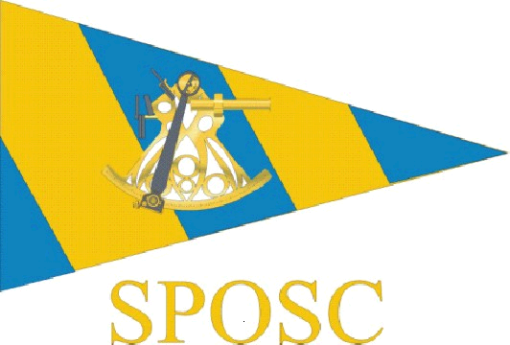

Sussex Police Offshore Sailing Club
Sussex Yacht Club
Shoreham
1900 hours Tuesday 16th June 2014

Committee Meeting - Minutes

The meeting was opened by Chair Anne Darling (AD) at 1920 hours.

Those present; Dave Frey (DF)
Dusty Miller (DM)
Owen Poplett (OP)
Freya Carter (FC)
Alwyn Evans (AE)

Apologies received from Steve Rigby, Graham Castell, Alan Haffenden, Alain Jacquet, Colin Jaques

- The minutes of the previous committee meeting held on 13/2/14 were agreed.

Matters arising
AE stated he has paid RNLI donation for cruising section. DF states he is yet to do this.
Action
DF - to ensure RNLI donation is paid from race section account

- PSUK 2014 event
DF updated the meeting with a brief talk through of the event. DM gave a brief account of events on the support boat.
Action
DF - to chase up Brian Donald for write up of race boat to go into Scuttlebutt
DM - to chase up write up for support boat

- Finances
DF states race section accounts currently showing surplus of around £220 after taking account of costs and crew payments for both PSUK and Met Open 2014.
AE states the cruising section have a surplus of £5170 which includes the additional SPSA funding of £1500 yet to be paid in
Actions
DF - has cheque to pay in to race account and will transfer to cruise account
AE - to refund support boat payment from CJ as he was replaced on trip by another paying member

- Charters
There was a discussion about upcoming events and participants.
Owners’ Rally – 2 boats expected beign ruby Tuesdfay with Graham Castell and Anta with Lenny Wheeler

Met Open 2014 – advert to go out in July. Skipper Steve Rigby with First Mate Alwyn Evans. Discussed possibility of a support boat on a 5 day charter and possible ½ week crewings. OP stated should be used for 50% new members. FC stated would like to Skipper – agreed by others present. DM willing to act as First Mate.
Action
FC - to advertise possible support boat, guage interest and arrange as necessary

Racing general - AE suggested chartering for race practice. DM suggested a race crew selection charter prior to PSUK events. Cost may be prohibitive as may be availability of members and/or skippers.
Action
AE - to check prices for practice day charter as has contacts within Sunsail.

Autumn Passage 2014 – AE will be skippering. Sunday 21st Sept for 5 days

Something Completely Different? – AD suggested consideration of entering other events such as Round the Island, Royal Escape, Cowes Week. May have same restriction as above due to cost and crew /skipper availability
Action
FC - to research alternative events and likely costs.

- Taster Sails
OP now has 44 expressions of interest from mainly newer members. This is encouraging but may not convert to actual attendees. There was general discussion about number of new members in relation to availability of charter/crewing opportunities. Further discussion about whether the Taster sails should be done in owners’ boats or in coded charter yachts. The group felt that the event is organised by the club, not just publicised by the club. There are serious potential insurance and liability issues raised by this were something to go wrong on board an owner’s boat during a club event, especially with potential novices on board. The Owners’ Rally was seen as possibly different in that the club merely facilitates contact between members and it is organised by the owners themselves who invite other persons to crew. As a result it was decided that the boat used for Taster Sails should be a coded charter vessel. How do other clubs operate – Wednesday and weekend racing from Brighton Marina for example?
Actions
OP – to consider dates, skippers, further details of costs etc. and get further advice from RYA / MCA regarding potential liability and insurance issues
DM – removing the Taster Sail ‘banners’ on the SPOSC weebly website. The page for owners and members to add their personal contact details, skills and availability remains as no club organisation is involved.

- Risk Assessment
AE has revamped and circulated the club risk assessment prior to the meeting. Feedback has been generally positive with some suggested revisions now included. The document has now been formally agreed and will operate with immediate effect. It will be circulated to skippers on all club events along with other documents.
There was also discussion regarding insurance and what cover (and level of cover) the club has, how it operates and the claim procedure. This was clearly an area which needed more information and it seems no one actually knows for sure.
Action
OP – will look into insurance cover and ascertain full details, including the position for current full and retired associate members.

- Date of next meeting
To be held on 12th August 2014 (suggested venue being the Cricketer’s PH at Berwick - DM to check availability and do provisional booking)

The meeting was closed by AD at 2120 hours

