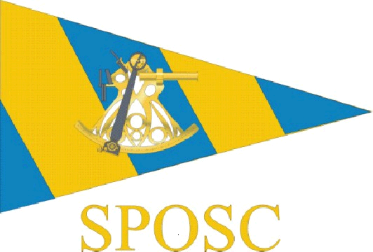

SUSSEX POLICE OFFSHORE SAILING CLUB
ANNUAL GENERAL MEETING

1915, Thursday, 23rd February 2012

Sussex Yacht Club, Shoreham

Minutes of Meeting

1. Apologies received

Alan Costello, Julia Beckett, Freya Carter, Alan Haffenden, Mike Tagg

2. Minutes of Previous Meeting (9th February 2011) and Matters Arising

There were no matters arising

3. Reports

- Treasurer’s reports - Alwyn Evans
- Secretary’s Report - Dave Frey
- Webmaster’s report - Dusy Miller
- Racing Report - Steve Rigby
- Cruising Report - Dusty Miller and Owen Poplett

  - Alwyn gave details of the financial position of the club which he described as healthy.

  - Dave reported that membership was showing signs of increasing following advertising of the club trips using the intranet

  - Dust gave an update on site statistics including a variety of hits from abroad. Of note was increased activity in connection with the additional publicity

  - Steve gave an update of how the race crew did in PSUK

  - Dusty and Owen gave updates on the cruising events from the previous year and spoke about arrangements for this years events

4. Committee Members and Representatives

The following positions were proposed;

Committee:

Chairman - Steve Rigby
Vice Chairman - Freya Carter
Secretary - Dave Frey
Membership Secretary - Owen Poplett
Treasurer - Alwyn Evans
Vice Treasurer - Tara McDonnell
Webmaster - Dusty Miller

Representatives:

East Sussex - Kevin Wallis
West Sussex & Gatwick - Alan Haffenden
Brighton & Hove - Anne Darling
HQ CID, Sussex House - Owen Poplett
HQ, Lewes - Julie Rainey

It was also agreed at the Committee meeting that Terry Clothier be proposed to remain as Commodore for the forthcoming year.

All positions were proposed and seconded and agreed by the members present at the AGM.

5. Club Rules Updates

- Agree current daily charges for ‘cruising’ and ‘racing’
- No other rule changes discussed

6. Proposed Club Events 2012

- Frostbite Owen Poplett March
- PSUK Steve Rigby May
- Owners Rally Lenny Wheeler
- Long Passage Trip Frank Hooper
- Met Open Steve Rigby

7. Club Trophies

- Commodore’s Shield Steve Rigby
- Roger Dice Trophy Dusty Miller
- Scuttlebutt Trophy Bob Trevis
- Portobello Cup

8. Any Other Business
There was no other business

9. Date of Next Meeting

January / February 2013 – date to be advised

