

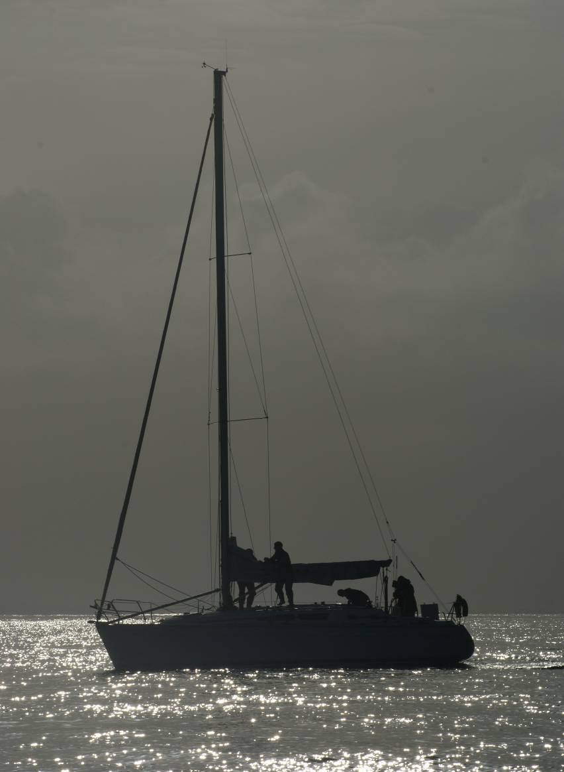j0343921Scuttlebutt

*Newsletter of the*

*Sussex Police*

*Offshore Sailing Club*

Issue 164

April 2010

Scuttlebutt No. 164

August edition 2009

********************************************

**CONTENTS**

1. **Dorset Police Open Dinghy Event**
2. **An Apology**
3. **N & NT Update**
4. **For Sale**
5. **PSUK 2010**
6. **RNLI**

COMMITTEE

Senior Flag Officer Commodore – Terry Clothier

##### OFFICERS OF THE CLUB

Chairman……………… Steve Rigby

Vice Chair……………. Freya Carter

Sec…………………… Julia Beckett

Treasurer……………… Alwyn Evans

Assistant Treasurer …… Tara McDonnell

## Asst. Sec and Membership Donna Powell

Web Master………….. Dusty Miller <http://sposc.weebly.com>

### REPRESENTATIVES

**West Downs** - Gill Hooton

**Brighton & Hove** Lindsey Valder-Davis

**North Downs** - Alan Haffenden

**East Sussex** - Donna Powell

**HQ** - Kevin Wallis

**Sussex House** - Martin Cheesman

**Gatwick -**

SCUTTLEBUTT

Editor ……………………… Terry Clothier [terryclothier@hotmail.com](mailto:terryclothier@hotmail.com)

Mediterranean Correspondent… John Sumner [johnsumner@wanadoo.fr](mailto:johnsumner@wanadoo.fr)

Caribbean Correspondent … Peter Kennett [peterkennett3@aol.com](mailto:peterkennett3@aol.com)

USA & Pacific Rim Correspondent Mark Hayler [vossen26@bellsouth.net](mailto:vossen26@bellsouth.net)

**Cover Photo – PSUK 2009 by Kevin Claxton**

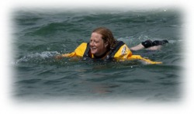

***Vice-Chair Freya Carter takes a swim***

**Dorset Police Dinghy Open Event, July 2009**

**By Dusty Miller**

Now sailing Dinghies can be tricky.

Many of our members started their sailing career racing dinghies and there were many mishaps on the way.

Here follows a sequence of photos taken at the Dorset Police Dinghy Open event held in Poole Harbour on Wednesday 8th July 2009 which features our Vice Chairperson and her helm who has in recent years been the Skipper of the Sussex support boat at the PSUK Offshore Championships.

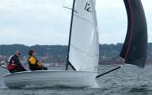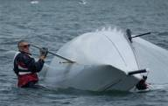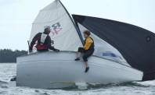

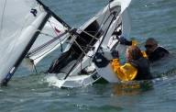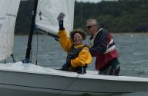

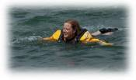

Freya was happy that she salvaged her lunch box and Dusty did not lose his sunglasses.

Freya should really use her legs more on the breast stroke!

It was not all bad news. They finished the event and were tenth overall.

**Regrets, I have a few!**

**By Terry Clothier**

The second item on the agenda must be an apology. It is some while since the last Scuttlebutt was sent out and I fully admit to failing in my duty. My poor excuse does involve a nautical theme, as around this time last year my Yachtmaster Offshore students coerced me, by means of bribery and alcohol, to run a Yachtmaster Ocean course. I succumbed to the temptation and agreed to run the course from September 2009 to March 2010 through the West Sussex Adult and Community Learning ‘shop’ at Littlehampton. Well, I had never taught this course before and it was some 13 years since taking the ‘Astro-Nav’ course myself so the re-learning curve was rather steep! Eleven enrolled on the course, so I had my work cut out, studying the material to keep one step ahead of the experienced sailors and Yachtmaster’s (including one former instructor) who turned up. One student had to withdraw from the course due to business pressures halfway through, but of the remaining ten, nine passed the final exam with flying colours. The tenth did not sit the exam from personal choice, although he did not miss a single lesson. Anyway I digress…. The work involved kept me from other duties and I regret that Scuttlebutt was the major casualty. I have offered to run another course next year, but the lesson plans are all complete and I trust that it will be easier second time around. I will now attempt to maintain this worthy publication, unless Mr Chairman decides to give me the sack!

It’s good to be back and I hope you enjoy the new copy……



**A Letter from Nigel and Nicki.**

**By Nigel Tinkler**

Hi Terry,

I have been talking to Alan Haffenden, and he suggested that you may like a small item for Scuttlebutt.

Nicki and I have just purchased a yacht. We have been looking for a boat for a little while, in an effort to find the right boat, for the last six years we have been chartering from a company (based in Chichester) called ‘Top Yacht’, they manage privately owned boats, all which are fitted out and maintained to a very high standard. We have been testing out different boats by chartering a variety within their fleet, looking for something that will enable us to spend half the year on it in the Med’. We have tried Moody’s, Bavaria’s, and Dufour’s from 26 ft up to 51 ft. The smaller boats were just that, too small for longer periods on board and the Dufour 51 was just a bit too heavy for two of us to handle over more than a couple of weeks. Well, Nicki for to handle. You see I am the skipper! So I steer the boat, Nicki handles the sails, the navigation, the boat cleaning,  sail trimming, and anything else that needs doing, although I do cook!

Last year we chartered a Dufour 38.5 called ‘Northern Soul’, she is a lovely boat, handles better than anything we have had in the past, twin helm,  three cabins, two heads and all the equipment you might need. She is just approaching 5 years old and we fell in love with her. At last years boat show we spoke to the company and then to the owner, as a result we made him an offer. Luckily he wanted to change to a catamaran as his wife did not like the tipping effect of a mono hull, so he was happy to accept our offer and we arranged to buy her. We have decided to leave her in the Top Yacht fleet for at least one more year, so you can see her by going to their web site, [www.top-yacht.com](http://www.top-yacht.com) and then going to the ‘Bareboat’ section.

After Nicki retires at the end of this year we will probably take the boat out of the fleet and spend 5-6 months a year on her in the med, its so much nicer than the Solent. As we like it so much we will start off in Turkey. The people are fantastic and providing you keep out of the bigger harbours there are still lots of tranquil places to stay. The water is so deep and bays shelve steeply allowing you to drop the anchor and back up to a rock (you can’t tie to trees any longer) and stay as long as you like for free. Visiting the locals you can purchase or barter for fresh veg or wander to the nearest market and buy food at very low prices. Where or when we move on from there will depend how the mood takes us. We already have a queue of friends waiting to try sailing for the first time. When we do spend more time on board we will send you a short diary of where we go, and hopefully we can help lots of friends enjoy the pleasure of sailing.

Nigel Tinkler

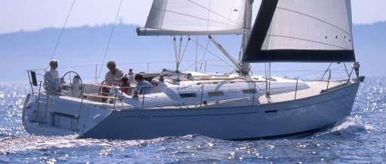

**Northern Soul**

Nigel, Nicki, perchance you would like to join in the owners rally this year? It will take place in the Solent between 28th June and 2nd July, 2010. For details contact the editor.

**News from the USA**

**From US Correspondent Mark Hayler**

For Sale; One Enterprise dinghy, in excellent condition with new (2006 and used once) road trailer and launching trolley. This fine example has a GRP hull and wooden decking which was professionally restored in 2006, the cover also being replaced the same year. She does need a new boom, but this is easily obtained locally. Don’t worry! You do not have to collect her from Atlanta as Mark has her safely stored on the Isle of Wight. Mark is looking for a nominal amount, around £350 and can arrange for continued storage at Seaview, Isle of Wight should you require it at a cost around £90 per annum. Should you wish to keep and use it there, Mark can also arrange accommodation nearby in a 4oo year old cottage with launching ramp 20 yards from the front door! If you are interested please contact the editor in the first instance, [terryclothier@hotmail.com](mailto:terryclothier@hotmail.com) and I will put you in touch with Mark.

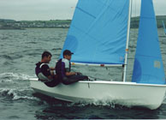

The Enterprise dinghy is a two person, non trapeze, non spinnaker one design double chine hull dinghy. Designed by Jack Holt in 1956, the design has withstood the test of time and the class provides some of the best sailing and racing to be found anywhere. Over 20,000 are registered worldwide. It has exellent qualities both as a cruising and two-person racing boat. The Enterprise dinghy is also very seaworthy and can be sailed offshore with confidence. N.B. The boat pictured is not Mark’s!

**PSUK 2010**

The Police Sport UK National Offshore Sailing Championship takes place this year, hosted by Kent using the Sunsail fleet from Port Solent. It starts on Sunday 16th May and Steve Rigby is skippering our race entry once again. There will no doubt be a write up following the event, but in the meantime we wish the race crew support boat and other club vessels attending a good week.

**RNLI Support**

As always, SPOSC supports the RNLI and crews contribute £1 per day on each trip to this worthy cause. Hopefully, none of us will need to call on their assistance, but it is a comfort to know that when you put to sea in UK waters there is someone to call when things go wrong. Secretary Julia Beckett received the following letter and certificate from the RNLI in response to last years donations.

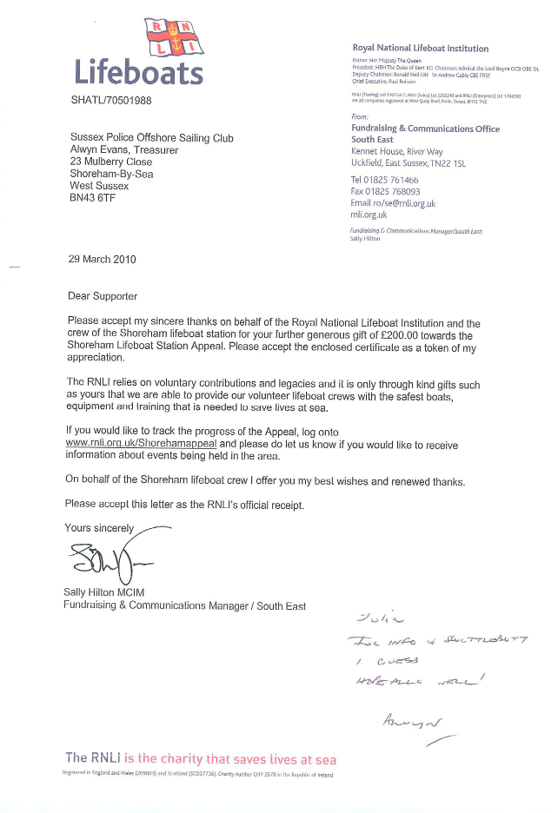

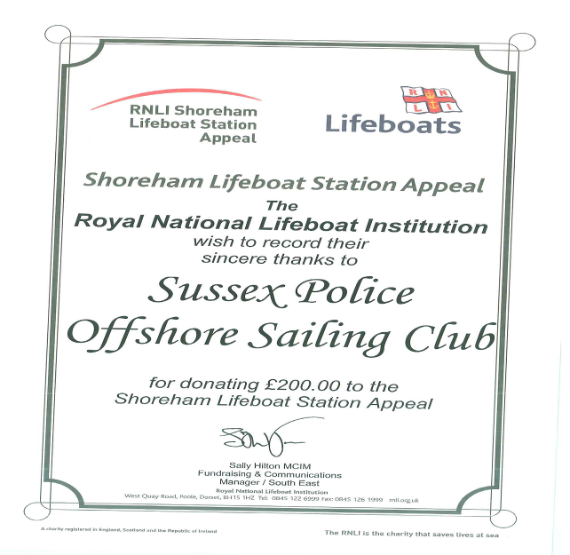

**Editorial Note**

Please remember that this is your magazine and should reflect your views and experiences for the benefit of other members. If you have any comment, articles or photographs you feel are appropriate for inclusion then please forward them to me [terryclothier@hotmail.com](mailto:terryclothier@hotmail.com) for publication.

*The opinions expressed in articles within Scuttlebutt are those of the individual only and not necessarily those of the Sussex Police Offshore Sailing Club. No responsibility can be accepted for any inaccuracies or omissions.*