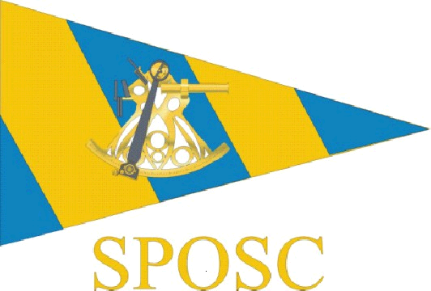

SUSSEX POLICE OFFSHORE SAILING CLUB
COMMITTEE MEETING

6pm, Thursday 9thDecember 2010
Greenhouse Effect Pub, Hove

Present: Steve Rigby (Chair)
Terry Clothier
Dusty Miller
Freya Carter
Alan Haffenden
Dave Frey
Tara McDonnell
Julia Beckett (Minutes)

1. Apologies

Alwyn Evans, Donna Powell, Gill Hooton, Lindsay Valder-Davis, Kevin Wallis

2. Minutes of Last Meeting (14 01 10) and Matters Arising

The minutes were agreed as accurate
All previous actions were discharged

3. Date and venue for AGM

Action: Julia and Dave Frey to liaise re booking of Haywards Heath Bar and Mezzanine Room for AGM in New Year

4. SPSA Meeting and Grant

The SPSA approved the changes to the club rules and this has been recorded in their minutes

The last grant cheque for 2010 has been received and paid into the SPOSC bank account

Action: TC to circulate amended club rules to committee members prior to the AGM
So they can be agreed and taken forward to AGM

Action: Julia to include Amended Club Rules as agenda item at AGM

5. Amendment of Membership Rules

Action: TC to circulate amended club rules to committee members prior to the AGM
So they can be agreed and taken forward to AGM

Action: Julia to include Amended Club Rules as agenda item at AGM

6. Election of Officers 2011

The following are proposed as committee members for 2010/11:

Chairman - Steve Rigby
Vice Chair - Freya Carter
Secretary - Julia Beckett
Membership
Secretary - Dave Frey
Treasurer - Alwyn Evans
Asst. Treasurer - Tara McDonnell
Webmaster - Dusty Miller

The following are proposed as Club Representatives for 2010/11

Kevin Wallis - East Sussex
Lindsey Valder-Davis - Brighton
Gill Hooton - West Downs
Alan Haffenden - North Downs
Mark Osbourne - Gatwick
Martin Cheesman - HQ CID

All of the above to be agreed by members at AGM

Action: Julia to e-mail members to see who might be interested in shadowing committee members with a view to possibly taking on vice committee roles from 2012, subject to members’ sanction. Anyone wishing to be a committee member must be a Sussex Police employee.

7. Election of Commodore 2011

The committee proposed that Terry Clothier should remain Club Commodore for 2011.

8. Issue of Club Trophies 2011

Commodore Shield: (for outstanding seamanship) - no nomination this year

Roger Dice Trophy: (for services to the club) - Dusty Miller for producing an
excellent website

Scuttlebutt Trophy: (best Scuttlebutt article) - TC to consider who should
receive this

Portobello Cup: (greatest RYA achievement) - Alan Costello

9. Finance

There is currently £1800 in the cruising account

The racing fund has £1,782-51.This includes £2k sponsorship monies received during PSUK 2009. A deposit of £300 has been paid to Sunsail for the PSUK 2011.

SR made the comment that the Met Police requested early deposits from forces to secure last year’s prices. However these have in fact gone down. This has meant an increase of £21.50 overall.

There is a loss of £100 on the year.

It was noted that the hire of racing boats is now more expensive than the hire of cruise boats due to insurance. TC proposed that crew fee for racing be increased to £30 + £1 RNLI contribution. FC commented that the club accounts are currently healthy and events have been subsidised. After a brief discussion it was agreed that the daily racing rate will be increased to £25 + £1 RNLI contribution with effect from the date of the AGM. The cruising rate of £20 + £1 RNLI contribution will remain the same.

It was acknowledged that these rates should be reviewed annually.

The accounts have been agreed and will be discussed at the AGM

10. Any Other Business

Wet weather gear

SR confirmed he currently has the wet weather gear.

PSUK AGM October 2010

TC attended the PSUK AGM. There were no issues. The Sussex PSUK 2009 accounts were agreed.

PSUK 2011 - 9th May 2011

This is being hosted by the Met Police. Sunsail fleet from Port Solent is being used – it is intended to hire their new 40 ft boats. Maximum crew level is 8. Cowes Yacht Haven is being used as the base.

SPOSC 2011 Sailing Calendar

It was agreed that the following events will be offered to Club Members for 2010

- PSUK 2011 – 8th – 13th May - PM and TMc have offered to skipper
the support boat
- Owners Rally – June - Action: TC to contact Lenny Wheeler
to see if he is happy to organise this
again
- Long Passage – Sept - Frank Hooper and Steve Rigby to
skipper
- Met Rally – Oct - Support Boat – PM and FC to
skipper if funding is available

TC and AE have discussed the possibility of a ‘sojourn for old salts’ event to be funded
from the cruising section.

Action: TC to discuss the ‘sojourn of old salts’ with AE and see whether this can be
funded from the cruising section.

11. Date of Next Meeting

SPOSC Committee - 5.30pm, Wednesday 9th February - Haywards Heath Police Station Sports & Social Club

SPOSC AGM - 6.30pm, Wednesday 9th February - Haywards Heath Police Station Sports & Social Club

